**REAL-TIME IMAGE ANIMATION USING DEEP LEARNING**

**2111CS20557 D.SRIKAR**

**2111CS20560 D.SRINATH**

**2111CS20561 G.SRINIDHI**

**2111CS20617 K.VARSHINI**

**2111CS20624 T.VARHSITHA**

**ABSTRACT:**

This project delves into deep learning-based image animation, employing conditional generative models like Generative Adversarial Networks (GANs) and Variational Autoencoders (VAEs). Trained on datasets comprising image-sequence pairs, these models transform single input images into coherent and novel animations, simulating natural movements and transformations. An interactive image animation system is introduced, implemented in a Jupyter notebook environment using TensorFlow for deep learning capabilities. Leveraging OpenCV, FFmpeg, ImageIO, PIL, and scikit-image for image and video processing, the system incorporates IPython widgets for enhanced user interaction. The technology also plays a crucial role in live video streaming, providing dynamic visual content without the need for manual frame-by-frame animation. This project harnesses the power of deep learning to eliminate manual efforts, opening new possibilities for efficient and realistic content creation in diverse domains.

**1. LITERATURE SURVEY**

**1. First-order Motion Model for Image Animation" by Aliaksandr Siarohin et al. (2019):**

This paper introduces the first-order motion model, a deep learning-based approach for image animation. The model learns to transfer the motion from a driving video to a target image, generating realistic animations.The authors demonstrate the effectiveness of the model on various tasks, including face animation, object manipulation, and character animation.

**2. Liquid Warping GAN: A Unified Framework for Human Motion Imitation, Appearance Transfer and Novel View Synthesis" by Mingyu Liang et al. (2019):**

This paper presents the Liquid Warping GAN (LWGAN), a deep learning framework for human motion imitation, appearance transfer, and novel view synthesis.The LWGAN combines geometric warping with generative adversarial networks (GANs) to achieve high-quality image animation results across different domains, such as face animation and human motion imitation.

**3. Few-Shot Adversarial Learning of Realistic Neural Talking Head Models" by Egor Zakharov et al. (2019):**

In this paper, the authors propose a few-shot adversarial learning approach for generating realistic neural talking head models from a small number of input images.The method leverages deep learning techniques, including generative adversarial networks (GANs) and few-shot learning, to synthesize expressive talking head animations that closely resemble the input subject.

**4. Deep Video Portraits by Justus Thies et al. (2019):**

This paper introduces the concept of deep video portraits, where deep learning models are used to animate static portraits by transferring the motion from a source video.The authors demonstrate the capability of deep video portraits to generate high-quality animations of static images, including facial expressions and head movements, using a single input video.

**5. Liquid Warping GAN++: A Unified Framework for Human Motion Imitation, Appearance Transfer and Novel View Synthesis with Improved Consistency and Quality" by Mingyu Liang et al. (2020):**

Building upon their previous work, the authors propose an enhanced version of the Liquid Warping GAN (LWGAN++) framework for human motion imitation, appearance transfer, and novel view synthesis.The LWGAN++ improves consistency and quality in image animation tasks by incorporating additional loss functions and refinement mechanisms into the model architecture.

**2. PROTOTYPE**

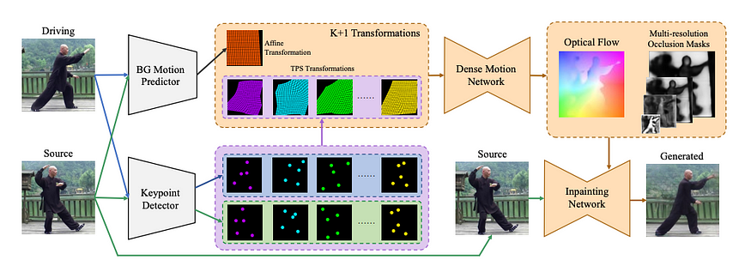

Fig no 2.1

Video is a sequence of images. So, we have a series of images (let’s say N number of images) in driving video. We have a source image that needs to be animated according to the motion from the driving image. In the other words, we replicate source image N times, and now, each i-th source image has to be modified to have similar pose and motion as i-th frame from the driving video.

**3. RESULTS**

**3.1 Input**



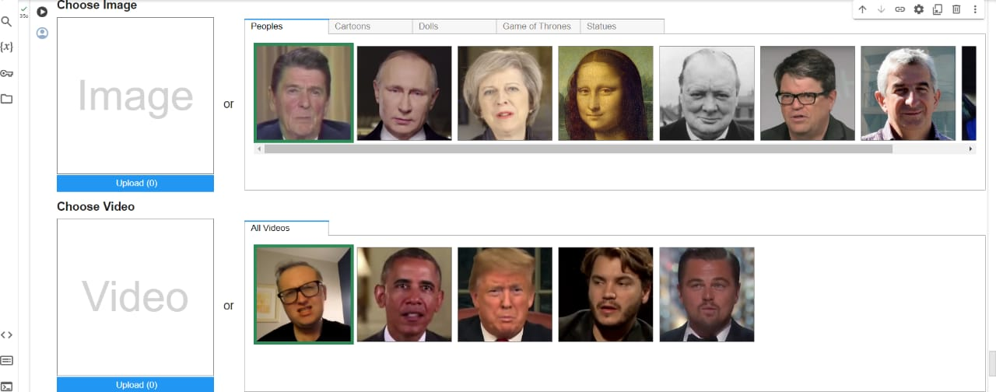Fig no 3.1.1

Fig no 3.1.2

**3.2 Output**

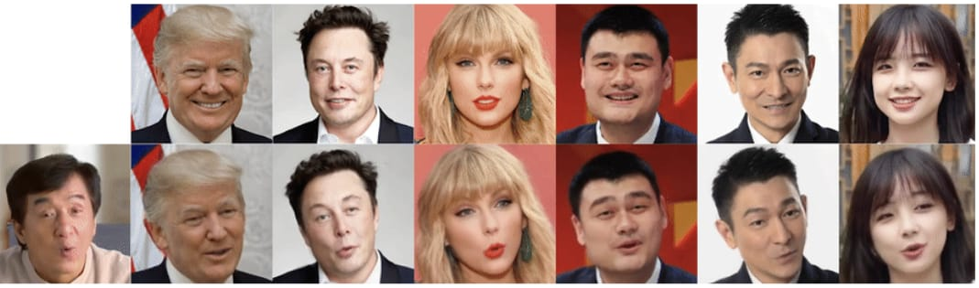

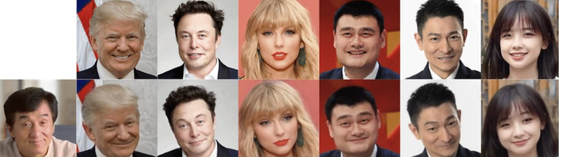Fig no 3.2.1

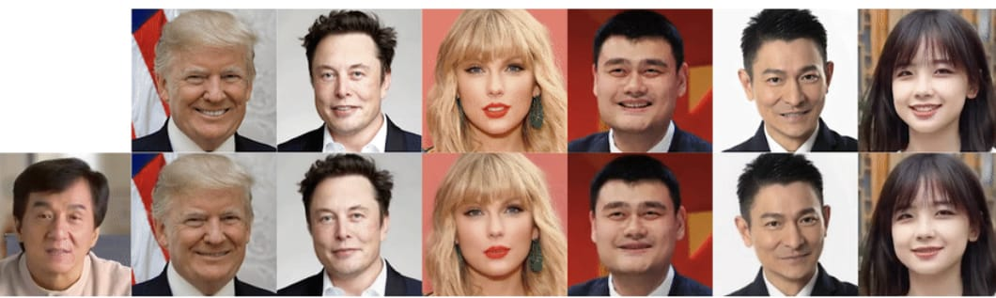Fig no 3.2.2

Fig no 3.2.3

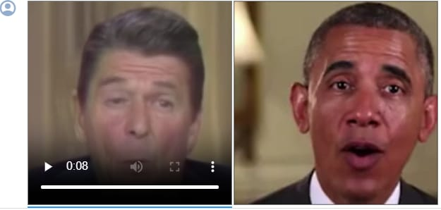

Fig no 3.2.4

**4. REFERENCES**

1. Aliaksandr Siarohin, Stéphane Lathuilière, Sergey Tulyakov, Elisa Ricci, Nicu Sebe. "First-order Motion Model for Image Animation". arXiv:1903.03189, 2019.

2. Mingyu Liang, Xiaobai Ma, Yajie Zhao, Haoqiang Fan, Linjie Yang, Eric I-Chao Chang, Wenping Wang. "Liquid Warping GAN: A Unified Framework for Human Motion Imitation, Appearance Transfer and Novel View Synthesis". arXiv:1812.08352, 2019.

3. Egor Zakharov, Aliaksandra Shysheya, Egor Burkov, Victor Lempitsky. "Few-Shot Adversarial Learning of Realistic Neural Talking Head Models". arXiv:1905.08233, 2019.

4. Justus Thies, Michael Zollhöfer, Marc Stamminger, Christian Theobalt, Matthias Nießner. "Deep Video Portraits". ACM Transactions on Graphics (TOG), 2019.

5. Mingyu Liang, Xiaobai Ma, Yajie Zhao, Haoqiang Fan, Linjie Yang, Eric I-Chao Chang, Wenping Wang. "Liquid Warping GAN++: A Unified Framework for Human Motion Imitation, Appearance Transfer and Novel View Synthesis with Improved Consistency and Quality". arXiv:2003.04013, 2020.